
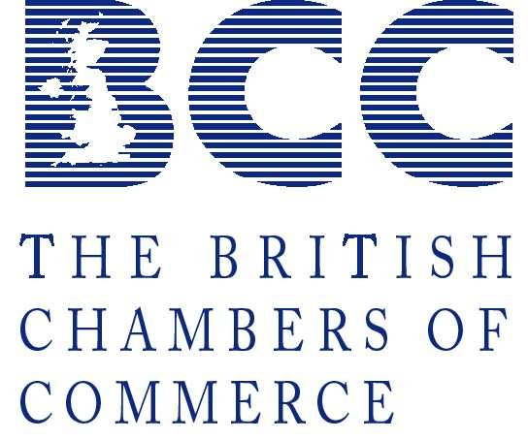

President HRH The Princess Royal Chairman David C H Ross, LL.B (Hons), N. P. Director Robert H. Leitch

CORPORATE CRIMINAL ACCOUNTABILITY

IN SCOTTISH BUSINESS

Accountability of Directors/Management

In the United Kingdom there are two kinds of criminal offence that a Company, Director or Senior Manager can commit in relation to worker and public safety:

- Regulatory Offences, like the Health and Safety at Work Act 1974
- Traditional crimes of violence like manslaughter

The current law does not impose safety duties on Company Directors. As a result Directors are not legally obliged to take measures to ensure that the company complies with safety law. This is bad for prevention and bad for accountability.

It is therefore difficult to sentence companies and organisations for criminal and Health and Safety offences.

Recent incidents

Despite investigations into public and private sector disasters such as the Zebrugge Ferry disaster, Piper Alpha and the Southall rail crash all revealing management failings, there have been no successful prosecutions for the hundreds of lives lost. Over three hundred people are killed each year as a result of corporate negligence, yet only three company directors have ever been successfully prosecuted for corporate manslaughter.
In May 2000, the government issued a consultation paper designed to overhaul the law on corporate responsibility and make an offence of corporate killing. Due for parliamentary discussion in 2003, the reforms would allow individual companies, organisations and their directors to be prosecuted for the accidental death of employees and members of the public.
In the light of this, we hear a wide range of arguments, from those opposed to the new reforms to those whose relatives were killed by criminal negligence and who advocate stricter accountability rules.

Over 300 people die due to work related incidents each year in the UK. Over 100 of these deaths are in the construction industry.
Currently the law is not much help since this area is covered by the crime of involuntary manslaughter, an offence that’s particularly difficult to apply to companies and corporations.
Despite a series of high profile disasters such as the already mentioned Zeebrugge Ferry disaster, the Bradford City fire, the Southall and Paddington rail crashes and others, there have been consistent failures in prosecuting those responsible. In fact there have only ever been as stated three successful prosecutions of Corporate Manslaughter, all of which involved small companies, making responsibilities for safety more easily identifiable.

Government Promises

The Labour government promised to reform the law on Involuntary Manslaughter in October 1997 and to introduce a new offence of Corporate Killing, to make companies take health and safety issues more seriously. The DETR and the Health and Safety Commission also produced a report entitled “Revitalising Health and Safety” in June 2000 in which they outlined Directors Duties and proposed percentage of profits fines for guilty companies.
These health and safety reforms also featured in the 2001 Labour Party Manifesto and in the Queens’ speech on 6 December 2000.

The Position of Scottish Business

Regional statistics produced on behalf of Scotland and outlined in the Safety and Enforcement Statistics Briefing Report show that in general Scottish businesses have a better performance in relation to Health and Safety Issues than other parts of the UK.

Scottish business is well aware of the need to look after employees and most businesses are highly responsible and take good care of their employees. Needless to say some businesses operate in dangerous areas such as opencast mining, the North Sea and Deep Sea Fishing to mention a few.

All of the businesses we have spoken with are concerned to ensure that their staff are safe at work and that they operate in an environment that will enable them to perform to the highest standards.

Both Government and business are becoming increasingly active in the field of Corporate Criminal Accountability and everyone agrees, that it is essential to put in place legislation that will ensure the safety of staff and the public whilst still allowing business to operate in an effective and efficient manner.

Legislative burden is always a concern of business so in developing policy to ensure ‘a fair deal for all’ it must be done in such a way as to ensure that there is not a disproportionate cost either in time or in resource.

Under current legislation it is difficult for a Director to be prosecuted, particularly in larger companies because of the difficulty of proving how responsible they are for a specific incident.

Whilst recognising the weakness of this position and underlining the need to ensure staff and public safety at all times, SCC feel that robust legislation must ensure companies and not individuals are held responsible for their contracts. Any legislation put in place should therefore concentrate on the robustness of the contract. Thereafter, the legislation should ensure that the systems within the company are competent in laying out the responsibility of all members of staff and should under investigation any member of staff have failed to comply with those rules, then they also should be taken to task. All of this must be undertaken in an environment that will ensure the safety of the public, whilst allowing the company to operate its business in a competitive way.

We believe therefore the change is needed, indeed long overdue and we urge all parties involved to act quickly to resolve the issues.

Bob Leitch
Director
Scottish Chambers of Commerce
October 2003

